**Market Research for Pick Me Up for MMU**

Pick Me Up for MMU is an app that could potentially replace applications like Grab and inDrive while serving as a medium for students to hitchhike to come to college or to travel to other places together. The main competitors of this application would be Grab, inDrive and AirAsia Ride. There are several aspects of E-hailing apps which makes the passengers experience smoother.

# Mapping structure

* Grab lets the user to ‘Choose from Map’. This allows user to pin their location or their preferred destination easily.
* InDrive lets the user to choose their location from the app itself, but it is not as smooth or savvy as Grab. The user can move around the map to choose their location but the user is not allowed to place the pick up/drop off spot wherever they want from the map itself (like Grab).

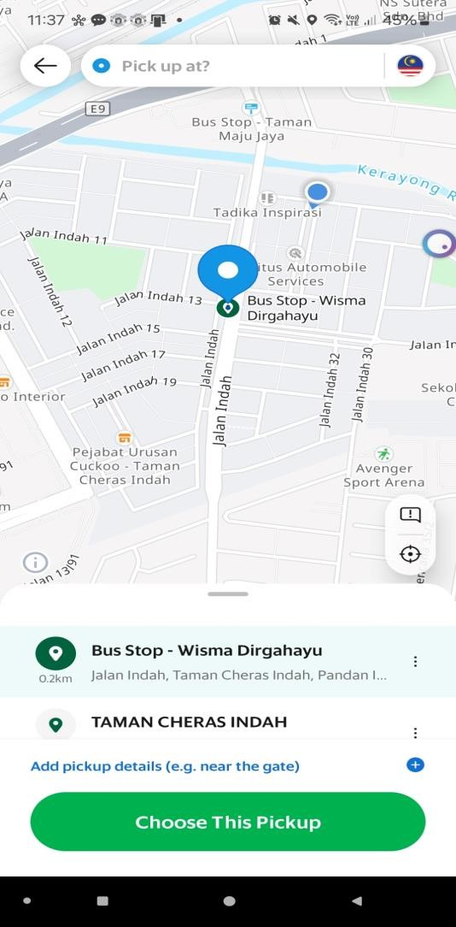 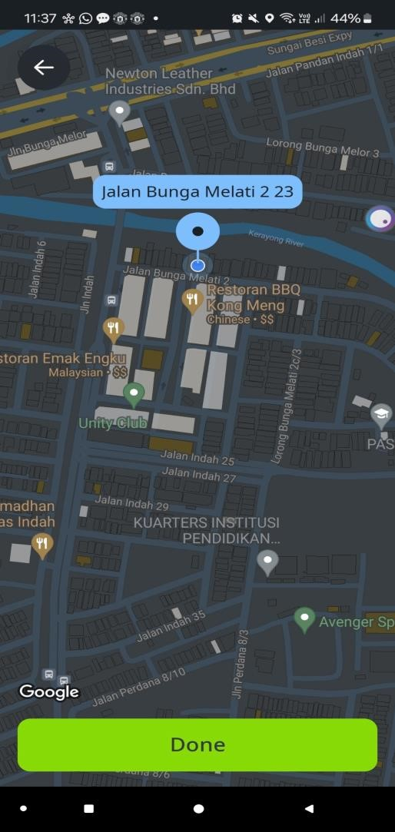

# Pricing

* Grab fixes the price of the fare when the user orders the e-hailing itself.
* InDrive allows the user to bid the price as high or as low as the user want. The driver can accept the ride they wish to accept in their own price(counterbidding).

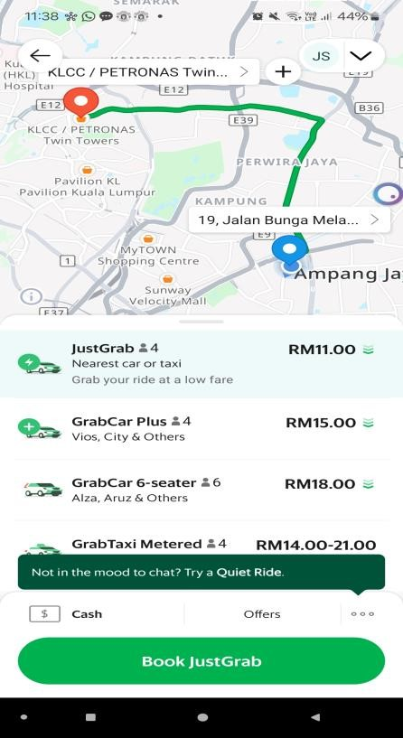 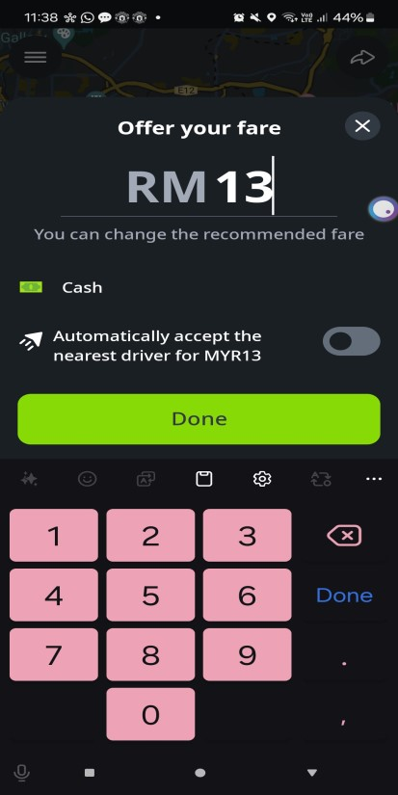

# In-App Messaging

* Grab prepares a space in the app for the user and driver to communicate more about the ride itself.
* InDrive prepares a space within the app for the user and driver to communicate more about the ride itself.
* Both apps’ messaging is savvy. The same system (or similar) could be implemented into ‘PMU for MMU’.

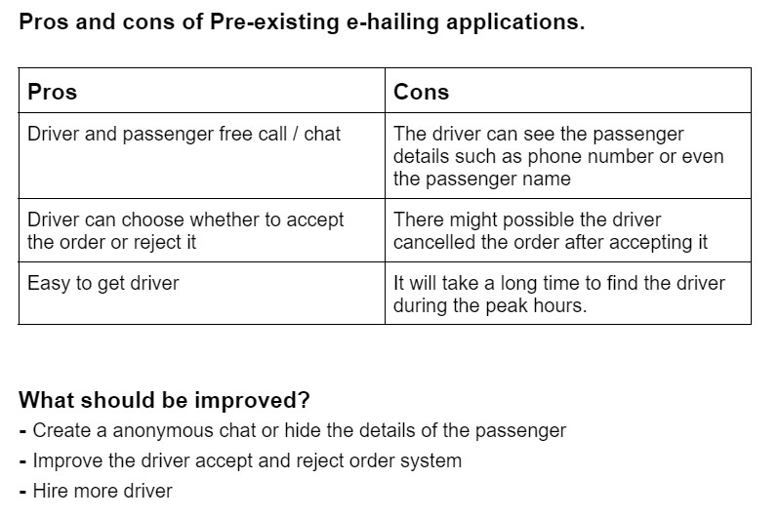

# 4.Lesser cashless payment options:

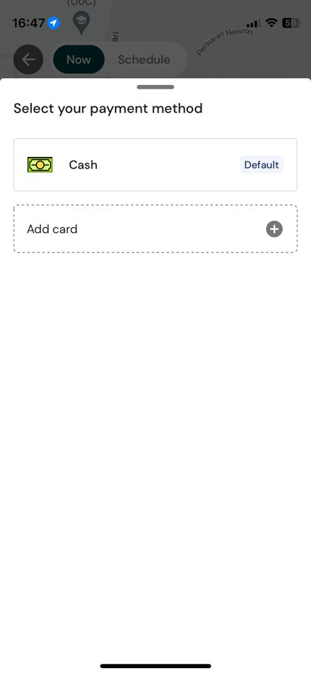

One major drawback of the Air Asia app is the limited availability of cashless payment options, such as the lack of support for popular services like TnG e-wallet and Apple Pay, which can inconvenience users who prefer or require these digital payment methods.

# **Conclusion**

This application could serve more as a bridge to connect students between different students from different faculties and also courses. There are many aspects and functions which could be implemented into the Pick Me Up for MMU app. There are also some down sides to the already existing applications. We as a group wish to better those aspects and create an application which could truly be useful for the MMU Community.